Adobe Creative Cloud for DSD Staff

Installation on Windows 10 District Staff Computers
- Press the Windows key to open the “Search” box and type “Software Center.”
- Click on Software Center in the results.
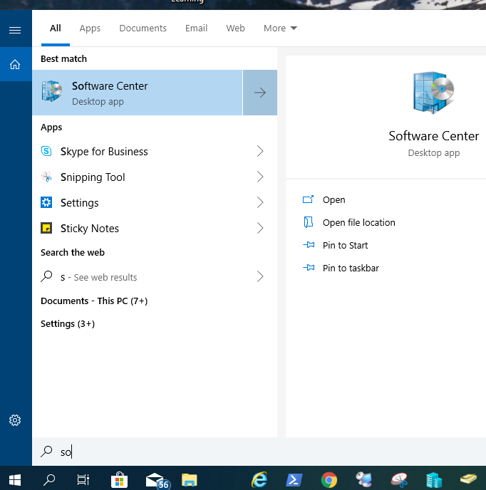

- Double-click on Adobe Creative Cloud Desktop. This will install the desktop icon. NOTE: This process can take several minutes.
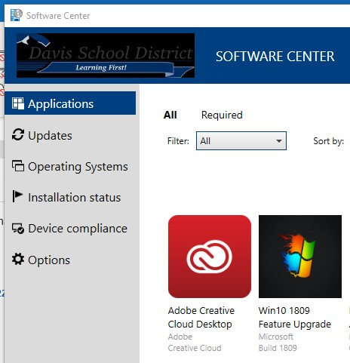

- When the installation process has been completed, the install Software Center may indicate that it has failed and to retry. Ignore this message if you receive it.
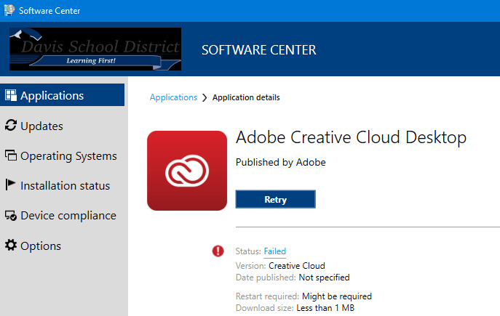

- Restart your computer.

- Double-click on the Adobe Creative Cloud icon on the desktop to launch the software. On the Adobe sign-in screen, login with your District email account and make sure to choose Enterprise ID. NOTE: This app may also do a self-update and you may need to login to your Microsoft account twice. However, you will only need to do this one time.
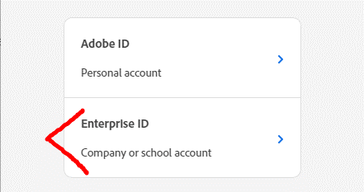

- After logging in with both your Adobe login (District email address) and your Microsoft login, the Creative Cloud grants you access to your Adobe apps. From here, you can install, update and uninstall desired apps.
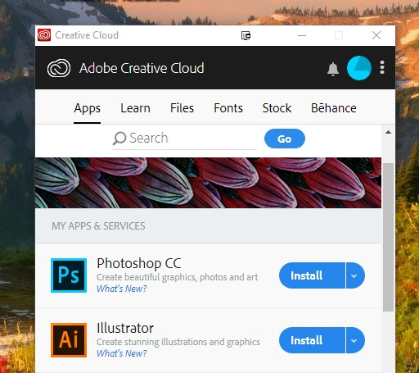

If you run into any problems with this process or need help, please contact your STS.

